الغلاف الخارجى للبحث

|  |  |  |  |  |  |  |  |  |  |
| --- | --- | --- | --- | --- | --- | --- | --- | --- | --- |
| أولاً: البيانات الخاصة بالطالب | | | | | | | | | |
| **الفرقة الدراسية** | **الثانية** | | | **التخصص** | | | **عام** | | |
| **اسم القسم** | **عام** | | | | | | | | |
| **اسم المقرر** | **هندسة البرمجيات-1** | | | | | | | | |
| **استاذ المقرر** | **دكتور/ عمرو غنيم** | | | | | | | | |
| ثانياً: البيانات الخاصة بالبحث | | | | | | | | | |
| **عنوان البحث** | **Bike Store and Blog project** | | | | | | | | |
| **طبيعة المشاركة** | **بحث فردى** | | | | | **بحث جماعى**  صح | | | |
| **ارسال البحث** | **بواسطة البريد الالكتروني** | | | | | | | | |
| **اسماء الطلاب المشاركين فى البحث**  **(يكتب الاسم رباعيا)** | **م** | **الاسم رباعى** | | | | **رقم الجلوس** | | | **الرقم القومى** |
| **1** | **مصطفى محمود عبد العزيز محمد** | | | | **2670** | | | **30003130102593** |
| **2** |  | | | |  | | |  |
| **3** |  | | | |  | | |  |
| **4** |  | | | |  | | |  |
| **5** |  | | | |  | | |  |
| **تاريخ الإرسال** | **/ 6 / 2020** | | | | | | | | |
| ثالثاً: البيانات الخاصة بالكونترول | | | | | | | | | |
| **النتيجة** | | | **ناجح** | | **راسب** | | | | |
| **أعضاء لجنة تقييم البحث** | **الاسماء** | | | | | | | **التوقيع** | |
| **1** |  | | | | | |  | |
| **2** |  | | | | | |  | |
| **3** |  | | | | | |  | |

|  |  |
| --- | --- |
| **فى حالة عدم قبول البحث يرجى ذكر الأسباب** | * **..............................................................................................................................................** * **..............................................................................................................................................** * **..............................................................................................................................................** * **.............................................................................................................................................** |

**11-c)List of Interfaces required:**

|  |  |
| --- | --- |
| User | Interface |
| New & Registered Users, Admins | 1-Login & Registration Page |
| Registered Users | 2-Forgot password Page |
| Registered Users, Admins | 3-Bike Renting Page |
| Registered Users, Admins | 4-Bike Cart Page |
| Registered Users, Admins | 5-Blog Page |
| Registered Users, Admins | 6-Bike Parts Page |
| Any Visitors | 7-About us Page |
| Registered Users | 8-Bike Page |

**14-Design some User Interfaces:**

**A)5W+H heuristic**

What & How:

The website will be viewed through a PC or Mac using a standard browser (v4+). Navigation and selection will be performed using a standard mouse and keyboard.

Many brochures will be presented for downloading in PDF format.

The different areas of the site will be accessible by;

• A menu-based navigation system combining 6 top menu items with submenus of no more than six clickable links that appear in drop down style with the mouseover event.

When & Where:

The site will be visited by users in a home or work environment.

A version of the site will be compatible with smaller mobile devices (iPad and iPhone). The site will be accessible at any time of day.

Who & Why:

It is expected that the visit majority of visitors will be bike enthusiasts.

**B) Interaction Paradigm:**

Internet/Web based network computing. Graphical and multimedia interface interpreted by a v4++ web browser, delivered over a network to desktop and mobile devices, themselves controlled by either 1) mouse and keyboard or 2) by touch screen and keyboard.

**C) Physical Computing Environment:**

The physical computing environment is, strictly speaking, the 300 million or so personal computers, kiosks and mobile devices that are connected to, and form, the Internet. Since this largest ever engineering feat is spread out geographically and offers content delivery for a variety of output devices and screen sizes, it is not possible to define the physical computing environment as a single, universally shared experience. Users may be sitting on a bus or walking down the street (iPad or iPhone) or at home with a 17 inch screen, at work with a 21-inch screen, or in a public library: the amount of physical space and the quality of the experience depends on the physical environment of each individual user.

**Part 4:**

**17)** **For the classes in your system, calculate all the following OO Complexity Metrics:**

**a)** WMC = The sum of Cyclomatic Complexity Metrics (CCM).

The CCM for:

Bike = 8.

Cart = 17.

dbConfig = 1.

Userclass = 9.

Forgetpass = 2.

Interactclass = 2.

WMC = 8 + 17 + 1 + 9 + 2 + 2 = 39.

**b)** The Depth of the Inheritance Tree (DIT) = 6.

**c)** The Number of Children (NOC) = the number of children for a class.

Login (NOC) = 3.

User Registration (NOC) = 1.

Bike (NOC) = 2.

RentBike (NOC) = 0.

PartBike (NOC) = 0.

Shopping Cart (NOC) = 0.

Payment (NOC) = 0.

Services (NOC) = 0.

Blog (NOC) = 0.

d) Coupling Between Objects (CBO) is the count of classes that are coupled to a particular class where the methods of one class call a method or access variables of the other class

e) Response for class (RFC) = the number of methods and the number of called methods in a class.

Login (RFC) = 3.

User Registration (RFC) = 13.

FPassword (RFC) = 1.

Blog (RFC) = 2.

Bike (RFC) = 4.

Services (RFC) = 9.

RentBike (RFC) = 7.

PartBike (RFC) = 7.

Shopping cart (RFC) = 7.

Payment (RFC) = 5.

f) LCOM is the Lack of Cohesion Of Methods it can be calculated by using this equation: LCOM = 1- which **(a)** is the number of instance variables and **(m)** is the number of the functions and constructors.

LCOM in Registration:

a = 12, m = 12, = 12.

LCOM = 1 – 12 / |12| |12| = 0,91.

LCOM Bike:

a = 3, m = 4, = 6.

LCOM = 1 – 6 / |4| |3| = 0,5.

LCOM Services:

a = 7, m = 8, = 14.

LCOM = 1- 14 / |8| |7| = 0,75.

LCOM RentBike:

a = 4, m = 5, = 8.

LCOM = 1 – 8 / |5| |4| = 0,6.

LCOM PartBike:

a = 4, m = 6, = 12.

LCOM = 1 – 12 / |6| |4| = 0,5.

LCOM ShoppingCart:

a = 3, m = 7, = 12.

LCOM = 1 – 12 / |7| |3| = 0,42.

LCOM Payment:

a = 3, m = 4, = 6.

LCOM = 1 – 6 / |4| |3| = 0,5.

LCOM Blog:

a = 2, m = 2, = 2.

LCOM = 1-2 / |2| |2| = 0,5.

**19)** 1-The Registration Function Testing:

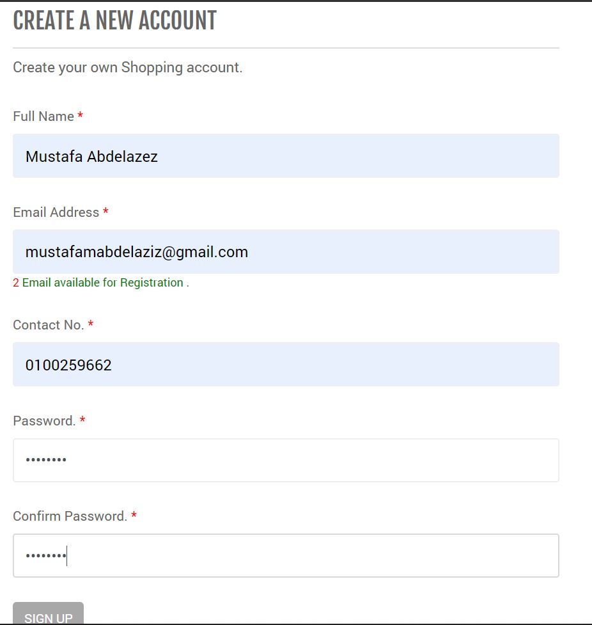

Here we have entered the fields required for the registration then we pressed Sign up button.

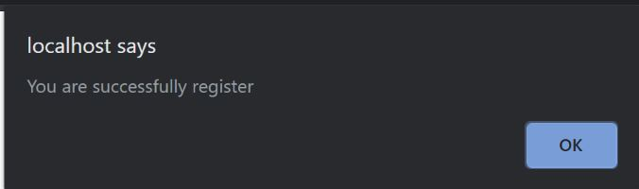

Then had this massage that confirms registering.

2- Login Function:

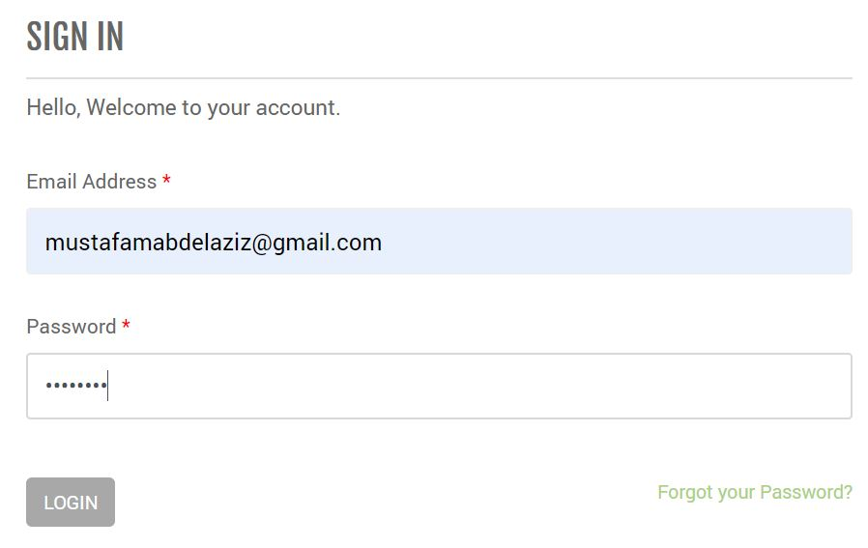

First, we Enter our login information then click login button.

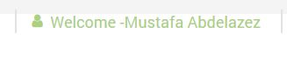

Logging in will appear to be successful as shown

3- Admin Logging in:

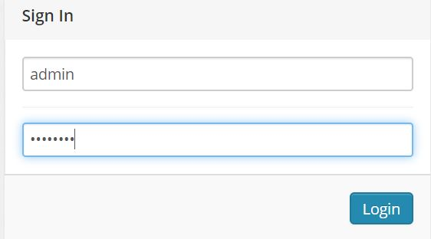

Enter the admin information.

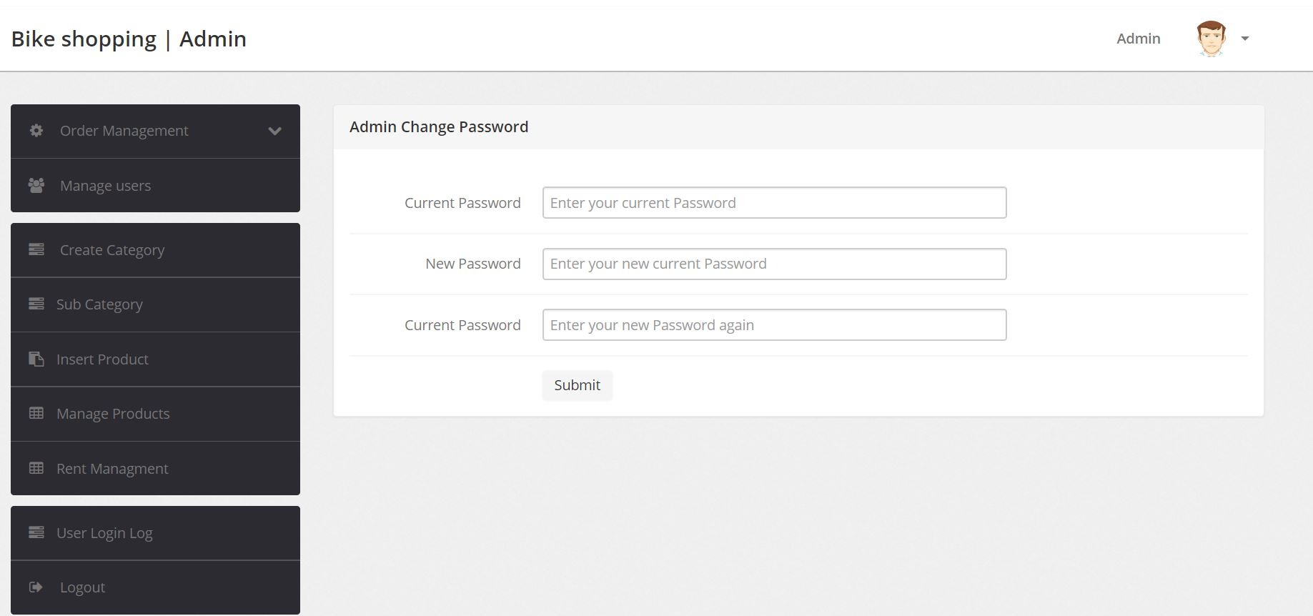

The admin profile was opened successfully.

4- Admin Manage users’ info:

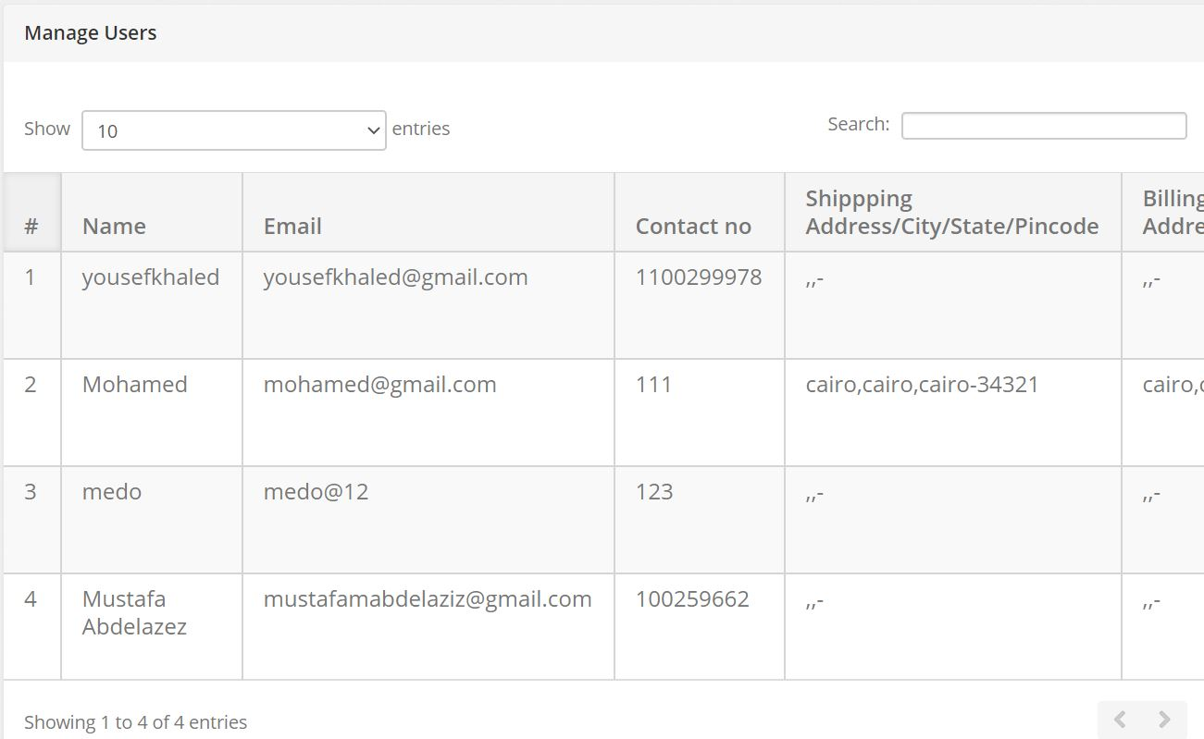

All user’s information is displayed.

5- Entering new category:

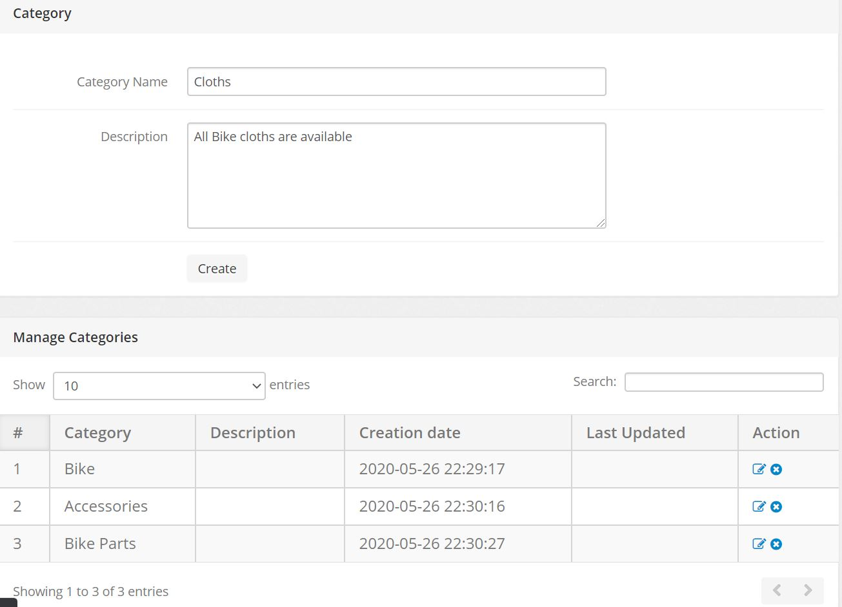

We Enter the category information then we press Create.

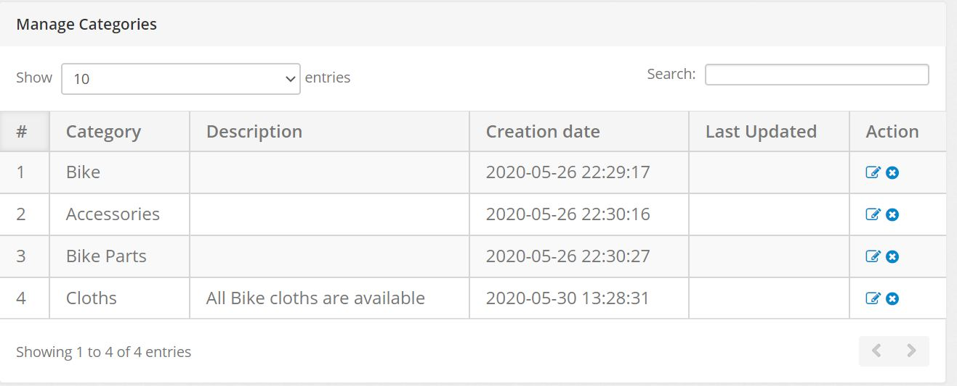

The category will be added successfully.

6- Adding Product:

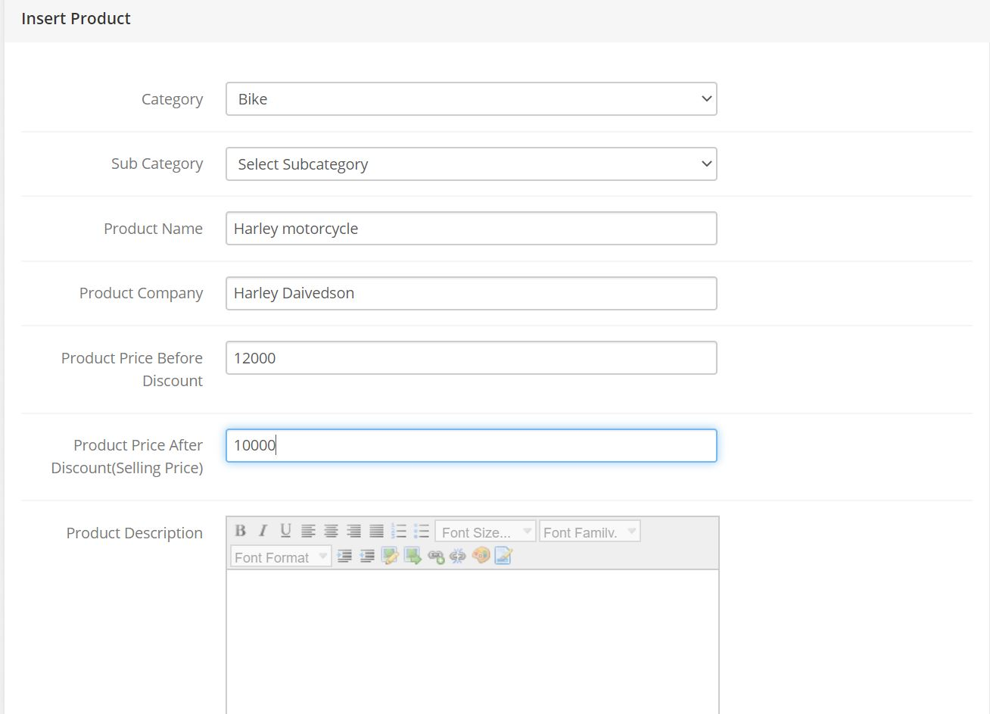Af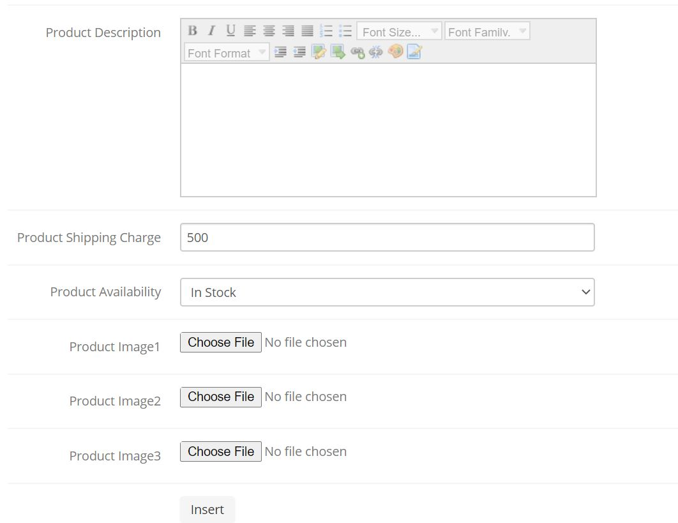

We should add All required information but, if we didn’t Enter all of it we will have an error massage.

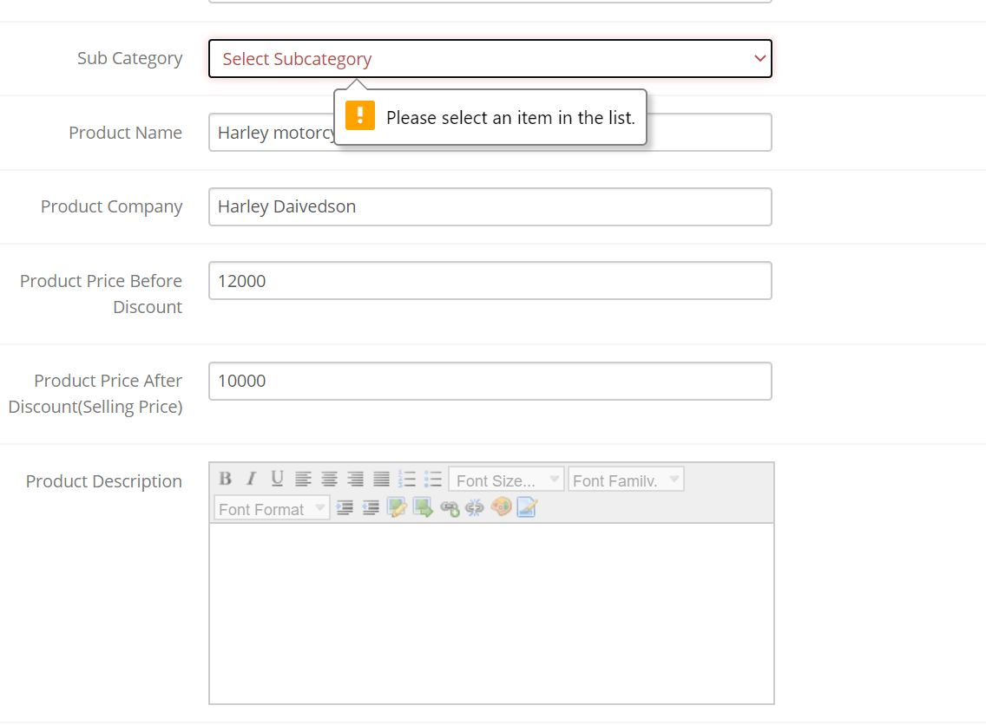

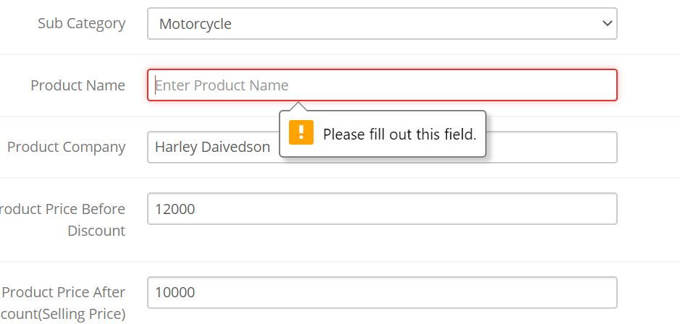

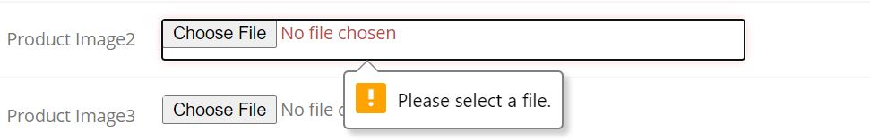

After we add all the required information, we can add our product successfully.



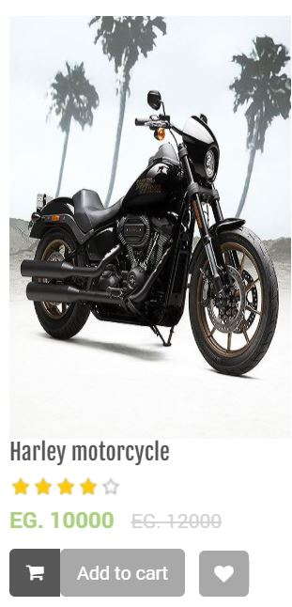

7- Sending Emails:

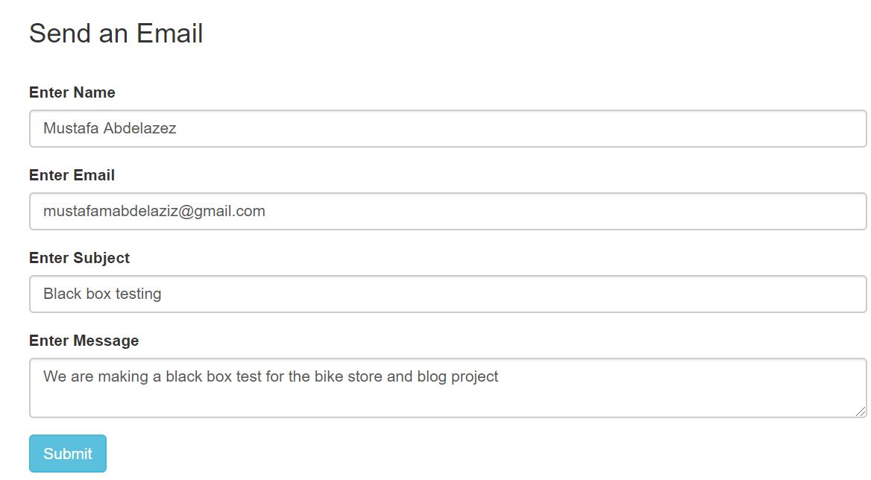

At first, we write our massage then we click submit.



Then we will see this to confirm that our mail was sent.